Name: RAJESHWAR RAO THAKKALLAPALLY

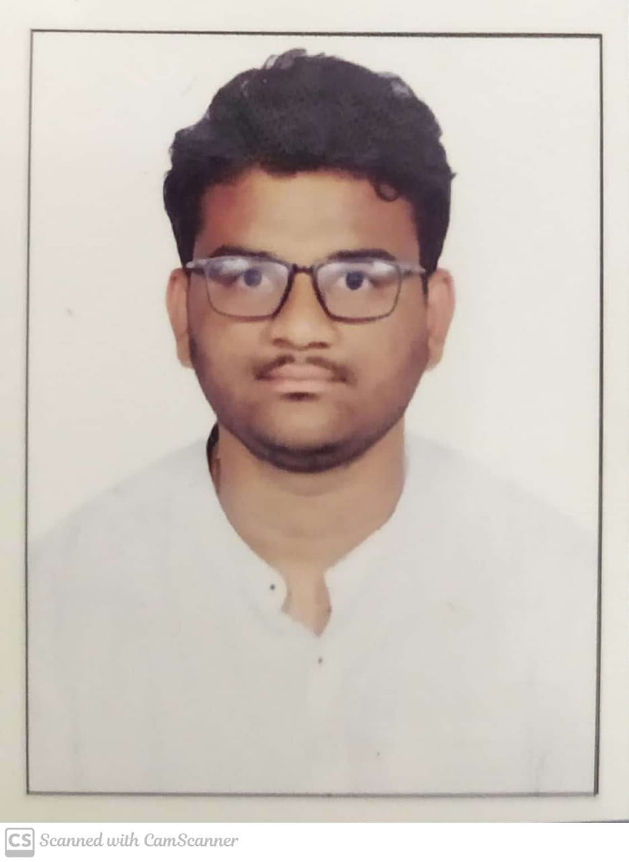

E-Mail: rajeshwarrao1256@gmail.com

Contact No: +919963323938

Address: H No:2-112/1, Bethigal, Veenavenka,

Karimnagar,Telangana.

# Career Objective

To work with an organization or company which offers challenging opportunities, an excellent cooperative working environment, enabling me to improve my abilities, develop my functionality, and improve the organization plans and work procedures.

|  |  |  |  |
| --- | --- | --- | --- |
| **Academic Details** | | | |
| **Course of Study** | **Name of the Institute** | **Duration of the Course** | **Aggregate** |
| **B.Tech - Branch** | VNR Vignana Jyothi Institute of Engineering and Technology (Information Technology) | 2018-Present | 9.46 |
| **INTERMEDIATE/ 10+2** | Narayana Junior College | 2016-2018 | 9.87 |
| **X CLASS/ SSC** | Tejaswi High School | 2016 | 10 |

# Technical Skills

* MERN Stack
* SQL
* Machine Learning
* Data Structures and Algorithms

**Programming Languages**

* Python
* Java

# Certifications / Courses Undertaken:

* Python – Certificate by A.V.R. Tecnosoft Solutions Private Limited
* R programming-Certificate by ACM VNRVJIET
* AWS Fundamentals ,Course

# Project Works:

**Title**: BLOOD BOON

**Technologies Used**: MERN Stack

**Description**: One of the life aspects whose importance is never faded or last in any country is the issue of health care ,As a result of this massive concern , blood donation is definitely a noble act. Many clinics and hospitals constantly require blood for several purposes all time.

* Registration required by the user to communicate for donating or accepting the blood via mobile
* Visual interface for the users to either update user information as donor via mobile
* Search for blood donors by acceptors in search engine
* Interface for acceptors to know the details about the donor
* Search for blood group in the blood banks will be available

**Title**: HOSPITAL MANAGEMENT SYSTEM

**Technologies Used**: Node JS , Mongo DB, Express, EJS, CSS, Bootstrap

**Description**: Hospital Management system includes registration of patients, storing their disease details into the system. It will also contain doctor’s information and availability of a doctor.

# Co-curricular Activities

* Volunteer in ACM Student chapter
* Coding Club Head

**Achievements**

* Won first price in J-HUB Hackathon conducted in state Level
* Selected for central level hackathon (SIH)

# Declaration:

To the best of my knowledge the above statements are true and I understand that withholding or misstating any fact may result in the refusal for placement.

Place: Hyderabad

Date: 10-1-2021

(Rajeshwar Rao)